SKILLS
+91 6382824329

tamilhacker550@gmail.com
cyberspark550@gmail.com

95/3 vasantha nagar,
Lalgudi-trichy 621601
Contact Us
ABOUT ME
2023
2019
2017
EDUCATION
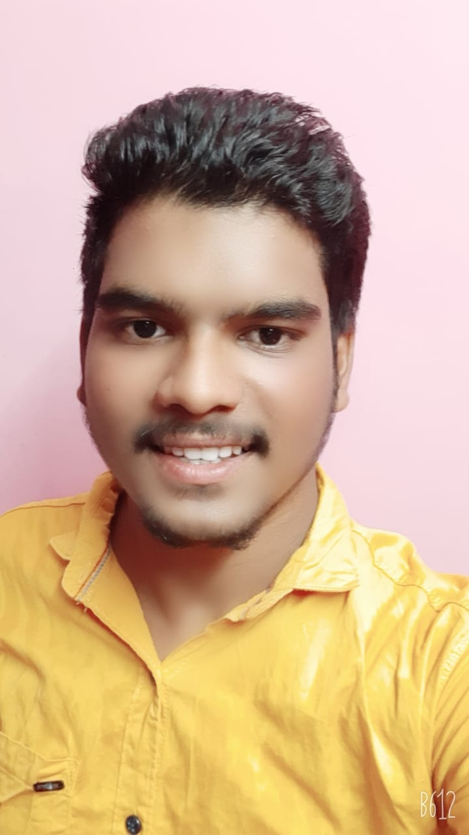
PRASANNA
KUMAR
CYBERSECURITY RESEARCHER&DEVELOPER

- 21y/o Studying Computer Science & Engineering at MIET
- Playing CTFs for tryhackme
- Busy in penetration testing

B.E Computer Science
M.I.E.T ENGINEERING COLLEGE

12th standard
Nest matriculation higher secondary school

10TH Standard
Nest matriculation higher secondary school

Web app penetration testing (9/10)
Networking (9/10)
Android app penetration test(6/10)
Malware analytics (5/10)
Binary exploitation (7/10)
Cyber forensics (7/10)

Developing skill

Interests & Hobbies
- Blogging
- Reading
- Travelling
- Ctf playing

PORTFOLIO


- HTML
- CSS
- JAVASCRIPT
- BOOSTRAP
- PYTHON

HTML
CSS
JAVASCRIPT
BOOSTRAP
NODEJS
C#
ELECTRON JS

